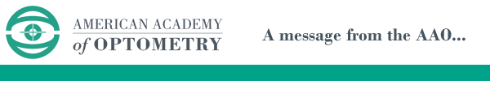

Date

Dear Dr. ( ):

Congratulations (First Name)! As your friend, I am recommending you to take the first step in “promoting the art and science of vision care through lifelong learning” by applying for Fellowship in the American Academy of Optometry (FAAO). As doctors, we are all looking to better ourselves and our patient care - Academy Fellowship offers many opportunities for scientific enrichment, leadership, prestige within optometry, and professional camaraderie.

The point system to sit for Fellowship has become more streamlined recent years, and most of our Fellow members are currently practicing ODs just like you and me.You can find more detailed information regarding Fellowship requirements at the following webpage: http://www.aaopt.org/becoming/efellowship.

Please let me know if you are interested in discussing your Candidacy for Fellowship. Either I or a member of our Membership Committee would be happy to discuss the process with you further, either by email, phone, or in person at Academy 2020 Nashville.

I look forward to learning more about you and your career path and interests, and how I can help you to reach your goals.

Your friend,

____________________

